1. **Number systems:**

* Number system is a way to represent numbers
* To a computer everything is a number, letters punctuation sound pictures etc.
* A set of values used to represent different quantities is known as number system.
* Total number of digits used in a number system is called its base or radix
* The **radix** or **base** is the number of unique [digits](https://en.wikipedia.org/wiki/Numerical_digit), including zero, used to represent numbers in a [positional](https://en.wikipedia.org/wiki/Positional_notation) [numeral system](https://en.wikipedia.org/wiki/Numeral_system). For example, for the [decimal](https://en.wikipedia.org/wiki/Decimal) system (the most common system in use today) the radix is ten, because it uses the ten digits from 0 through 9.
  + Written after number as a subscript e.g. (256)10
* Important number systems are as follows
  + Binary number system
  + Decimal number system
  + Octal number system
  + Hexadecimal number system
* **LSB least significant bit** 
  + Is the digit in a number that has the least effect on that number
  + Any change in LSD will have minimal effect the value
  + Non zero digit
  + Farthest right
* **MSB (most significant bit)** 
  + is the digit in a number which can affect the number significantly
  + the value of the number having the greatest amount is either increased or decreased.
  + Non zero digit of a number
  + Farthest left

e.g. in number 45356 4 is MSB and 6 is LSB

* 1. **Binary number system**
* Digital computer represents all kinds of data and information in binary system
* Base/ radix is 2, and The two digits are "0" and "1"
* Important terms used in binary numbers are
  + Bit: smallest possible unit of data
  + Byte: group of 8 bits
  + Nibble: 4 bits, half byte
  + Word :2 bytes, 16 bits
  + With n bits we can represent 2n numbers e.g. with 2 bits we can represent 22 =4 values/binary numbers i.e. 00, 01, 10, 11

**Binary arithmetic**

* **Binary addition** 
  + Similar to decimal addition
  + Addition creates SUM bit and Carry bit
  + In case of 3 or more 1s follow LCM/conversion to binary
  + 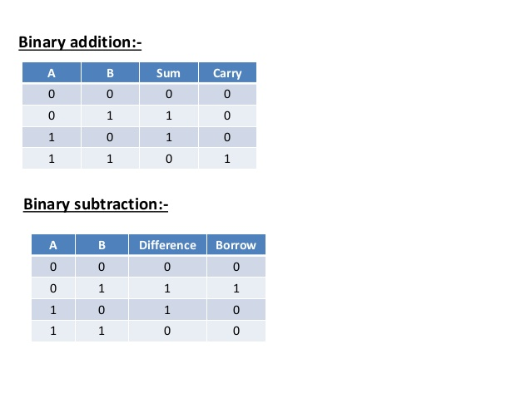

**Examples :**

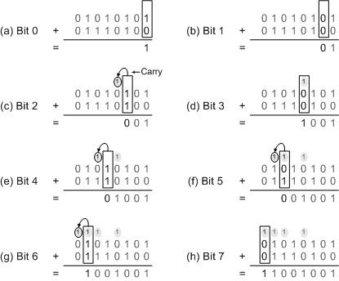

* **Binary subtraction**
  + Similar to decimal subtraction
  + If B is greater than A then 1 is borrowed from next position

**Examples :**

1. **Subtract 00110 from 10100 (6 from 20)**

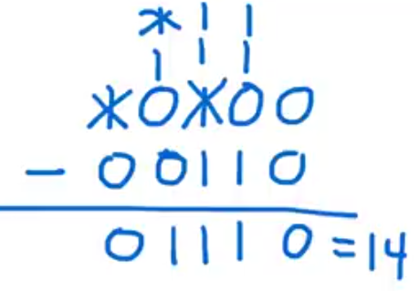

1. **Subtract 10011011 from 11001010( 155 from 202)**

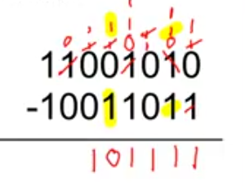

* **Binary multiplication**
  + Same as decimal numbers
  + Follows following rules
    - 0*0=0
    - 0*1=0
    - 1*0=0
    - 1*1=1

**Example multiply 1010 with 1011(10 with 11)**

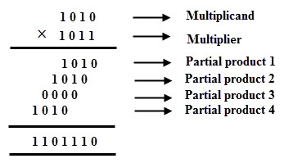

* **Binary division** 
  + Similar to decimal division
  + Division occurs only if dividend is greater than or equal to divisor
  + If dividend is less than divisor, then add 0 to quotient and bring down another bit
  + Divide 510 by 5 for understanding
  + Divide 173 by 14; 127101 by 121 for undertanding
  + Divide 01001101 by 111

**Examples divide 1010 by 10 (10 by 2)**

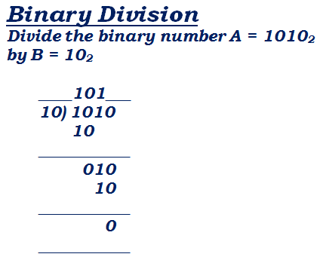

**Example 2 : divide 01001101 by 111(77 by 7)**



What will happen if you change the second last bit of dividend? Replace it with 1?

* 1. **Decimal number system**
* Most commonly used number system
* Base 10
* Consists of 10 digits from 0-9
  1. **Octal number system**
* Base 8
* Consists of 8 digits from 0 to 7
  1. **Hexadecimal number system**
* Base 16
* Consists of 16 numbers form 0 to 15, where 10 11 12 13 14 and 15 are represented by A, B,C,D,E,F respectively.

**CONVERSIONS**

Possible conversions are

1. Decimal to binary
2. Decimal to octal
3. Decimal to hexadecimal
4. Binary to decimal
5. Binary to octal
6. Binary to hexadecimal
7. Octal to binary
8. Octal to decimal
9. Octal to hexadecimal
10. Hexadecimal to binary
11. Hexadecimal to octal
12. Hexadecimal to decimal
13. ***Conversion of binary to decimal:***

To convert a binary number to a decimal number, we multiply the number by 2 and then add it to the product of next immediate number by 2. In the end the 2’s in the sum are given powers depending on the place of number it is multiplied to.

***Example:***

Convert 11010101 to decimal.

$$1×2^{7}+1×2^{6}+0×2^{5}+1×2^{4}+0×2^{3}+1×2^{2}+0×2^{1}+1×2^{0}$$

$$128+64+0+16+0+4+0+1$$

$$213$$

1. ***Conversion from binary to octal:***

**Method -1:**

To convert from binary to octal number system, we 1st convert the number to decimal, and then convert it to octal by division. Taking the above example further, we convert the number 11010101 to octal.

***Example:***

Convert 11010101 to octal.

**Step 1:**

The 1st step is to convert the number to decimal:

$$1×2^{7}+1×2^{6}+0×2^{5}+1×2^{4}+0×2^{3}+1×2^{2}+0×2^{1}+1×2^{0}$$

$$128+64+0+16+0+4+0+1$$

$$213$$

**Step 2:**

The next step is the division by 8.

|  |  |
| --- | --- |
|  | 213 |
| 8 | 26 ------------- 5 |
| 8 | 3 -------------- 2 |

So the octal representation of (11010101)2 is (325)8

**Method -2:**

The 2nd method is to divide the numbers in the groups of 3, starting from the end (i.e right) and then representing each group as an octal number. If the ending group has less than 3 numbers, add 0’s to the left of that number.

***Example:***

Convert 11010101 to octal.

Divide in the groups of 3 starting from the end.

11 010 101

Add zero to the right of 1st group to complete a group of 3 numbers.

011 010 101

Now in octal,

011 = 3

010 = 2

101 = 5

So, (11010101)2 is (325)8

1. ***Conversion of Binary to Hexa-decimal:***

Conversion of binary to hexa-decimal is same as conversion to octal, except that now the decimal number is divided by 16 i.e with the base of hexa-decimal.

***Example:***

Convert 11010101 to octal.

**Step 1:**

The 1st step is to convert the number to decimal:

$$1×2^{7}+1×2^{6}+0×2^{5}+1×2^{4}+0×2^{3}+1×2^{2}+0×2^{1}+1×2^{0}$$

$$128+64+0+16+0+4+0+1$$

$$213$$

**Step 2:**

The next step is the division by 16.

|  |  |
| --- | --- |
|  | 213 |
| 16 | 13 ------------- 5 |

So the hexa-decimal representation of (11010101)2 is (D5)8

**Method -2:**

The 2nd method is to divide the numbers in the groups of 4, starting from the end (i.e right) and then representing each group as a hex number. If the ending group has less than 4 numbers, add 0’s to the left of that number.

***Example:***

Convert 11010101 to hexa-decimal.

Divide in the groups of 3 starting from the end.

1101 0101

Now in octal,

1101 = D

0101 = 5

So, (11010101)2 is (D5)8

**Conversion of decimal to any other number system**

* Divide repeatedly decimal integer by the base of the number system in which the number is to be converted until it is no more divisible
* Write remainder in reverse order to get the converted number

1. ***Decimal to binary***

***Example:***

Convert 213 to binary.

|  |  |
| --- | --- |
| 2 | 213 |
| 2 | 106 ------- 1 |
| 2 | 53 -------- 0 |
| 2 | 26 --------- 1 |
| 2 | 13 --------- 0 |
| 2 | 6 ----------- 1 |
| 2 | 3 ---------- 0 |
| 2 | 1 ---------- 1 |

So, (213)10 in binary is (11010101)2

1. ***Conversion of decimal to octal:***

Conversion of decimal to octal is same as conversion to binary. The division in this case is done using the base of octal number system i..e 8.

***Example:***

Convert 213 to binary.

|  |  |
| --- | --- |
|  | 213 |
| 8 | 26 ------------- 5 |
| 8 | 3 -------------- 2 |

So the octal representation of (213)10 is (325)8

1. ***Conversion of decimal to hexa-decimal:***

Conversion of decimal to octal is same as conversion to binary. The division in this case is done using the base of hexa-decimal number system i..e 16.

|  |  |
| --- | --- |
|  | 213 |
| 16 | 13 ------------- 5 |

So the hexa-decimal representation of (213)10 is (D5)16

1. ***Conversion of octal to binary:***

To convert an octal number to binary, we divide each octal number by 2 until the number is no more divisible. Each binary number must contain 3 binary digits, if not so, we add a zero to beginning of the binary number.

***Method 1:***

***Example:***

Convert (325)8 to binary.

|  |  |
| --- | --- |
| 2 | 3 |
|  | 1 ----- 1 |

|  |  |
| --- | --- |
| 2 | 2 |
|  | 1 ----- 0 |

|  |  |
| --- | --- |
| 2 | 5 |
| 2 | 2 ----- 1 |
|  | 1 ------ 0 |

3 = 11 = 011

2 = 10 = 010

5 = 101

So, (325)8 = 011 010 101 = (11010101)2

**Method 2:**

Step 1: covert octal to decimal

Convert decimal to binary

1. ***Conversion of Octal to decimal:***

To convert an octal number to decimal, we multiply each number by 8 and add a power 8 to depending upon the place of octa number, and the sum all the products.

***Example:***

Convert (325)8 to decimal

Hence the decimal of (325)8 is 213.

1. ***Conversion of Octal to Hexa-Decimal:***

To convert from octal to hexa-decimal, we write the octal number as a binary number 1st. Then, we group the binary number in a group of 4. Then write those binary values as hex numbers.

***Example:***

Convert (325)8 to hexa-decimal

3 = 11 = 011

2 = 10 = 010

5 = 101

So, (325)8 = 011 010 101

In the group of 4’s,

0 1101 0101

Ignore the 1, as it is insignificant.

Now, the hex of 1101 is 13 which is D and hex of 0101 is 5.

So the hexadecimal number is D5.

**Method 2:**

Step 1 : convert octal to decimal

Covert decimal to hexa-decimal

1. ***Conversion from hexa-decimal to binary:***

The conversion of hex numbers to binary is similar to octal to binary conversion. The numbers are separately divided by 2 and written in groups of 4 binary numbers for each number.

***Example:***

Convert (D5)16 to binary.

D=13

|  |  |
| --- | --- |
| 2 | 13 |
| 2 | 6 ------ 1 |
| 2 | 3 ------ 0 |
|  | 1 ------- 1 |

|  |  |
| --- | --- |
| 2 | 5 |
| 2 | 2 ---- 1 |
|  | 1 ---- 0 |

D=1101 5=101=0101

(D5)16 = (11010101)2

1. ***Conversion of hexa-decimal to Decimal:***

To convert a number from hexa-decimal to decimal, we multiply each number by 16 and then add the terms. The 16 carries a power relative to the place of number it is multiplied to.

***Example:***

Convert (D5)16 to decimal.

$$D×{16}^{1}+5×{16}^{0}$$

$$208+5$$

$$213$$

1. ***Conversion of hexa-decimal to octal:***

Separate the digits of the given hex number, if it contains more than 1 digit. Find the equivalent binary number for each digit of hex number. Divide them in the groups of 3 and write the octal for each group. If there are less than 3 numbers left for last group, just add a zero to the beginning of number.

***Example:***

Convert (D5)16 to octal.

D=1101 5=0101

Groups of 3:

11 010 101

Add a zero to the beginning of 11.

011 010 101

Now assign octal number to each group:

011 = 3 010 = 2 101 = 5

Hence octal for (D5)16 is 325.